# Project Plan

Client: City of Pasadena

Project Name: UMGC-Chatbot

Project Manager: Joseph Ogunsanya

Synopsis: This plan converts the Chatbot

Version: V3.0

Issue Date: April 5, 2020

Distribution: Dr. Assadullah

Prepared by:

- Joseph Ogunsanya

- Helen Abraham

- Evelyn Akinlosotu

- Essaid Elboukhani

- Jan (Jon) Masouh

- Romuald Priva Leuga Nousibouaba

- Vincent Seen

Authorized by:

Dr. Assadullah

Mr. Del Toro

**Amendment History**

|  |  |  |
| --- | --- | --- |
| **Version Number** | **Issue Date** | **Changes** |
| 1.0 | 02/23/2020 | The initial version of the Chatbot project plan |
| 2.0 | 03/21/2020 | Implement the instructor feedbacks |
| 3.0 | 04/5/2020 | Formatted the document and implementing more instructor feedback |
|  |  |  |

**Table of Contents**

Table of Contents ii

List of Figures xiv

List of Tables xv

1 INTRODUCTION 1

1.1 Document Purpose 1

1.2 Associated Documents 1

1.3 Project Plan Maintenance 2

2 PROJECT SCOPE 3

2.1 Outline of Client’s Objectives 3

*2.1.1* *Objectives 3*

*2.1.2* *Success Criteria 4*

*2.1.3* *Risks 4*

2.2 Outline of UMGC Team 2 Objectives 5

*2.2.1* *Objectives 5*

*2.2.2* *Success Criteria 5*

*2.2.3* *Risks 5*

2.3 Definitive Scope Statement 5

3 DELIVERABLES 6

3.1 To Client 6

3.2 From Client 6

4 PROJECT APPROACH 7

4.1 Project Lifecycle Processes 7

4.2 Project Management Processes 8

4.3 Project Support Processes 9

4.4 Organization 9

*4.4.1* *Project Team 9*

*4.4.2* *Stakeholders Mapping 9*

5 COMMUNICATIONS PLAN 10

6 WORK PLAN 11

6.1 Work Breakdown Structure 11

7 MILESTONES 15

8 PERFORMANCE AND METRICS 16

9 RISKS, CONSTRAINTS, ASSUMPTIONS, DEPENDENCIES 17

9.1 Risks 17

9.2 Constraints, Assumptions and Dependencies 17

10 FINANCIAL PLAN 19

**List of Figures**

**Figure 1. Project Phases** 7

**Figure 2. Stakeholders Mapping** 9

**Figure 3. Resources/Work Resources** 13

**List of Tables**

**Table 1. Communications Matrix** 10

**Table 2. Project Tasks** 11

**Table 3. Project Milestones** 12

**Table 4. Resource Stats** 13

**Table 5. Milestones** 15

**Table 6. Associated Risks** 17

# INTRODUCTION

## Document Purpose

The purpose of this document is to show an outline of the Chatbot software that UMGC City Team 2 will develop. The Chatbot software project is part of the UMGC City project for the City of Pasadena in California. This document will extract information from the City of Pasadena’s website to create a Chatbot that is able to answer users’ questions and lead them in the correct direction. This document explains how Team 2 will complete the four milestones that lead to the delivery of the project.

## Associated Documents

The following includes the documents associated with the first milestone:

* Work Breakdown Structure ([WBS](https://drive.google.com/open?id=1UlXHnKNZLa8eg8ZpnCVL7zcRYRuBwQ4v))
* Change Request
* Milestones Document
* Risk Management

## Project Plan Maintenance

The project plan updates will be conducted by the team leads of each role. All minor updates will be added to the amendment history at the top of this project plan document. Every major change will require approval, using the change management document, from the customer and stakeholder. Once approved by the customer and stakeholder, the change management document and the amendment history will be updated.

# PROJECT SCOPE

## Outline of Client’s Objectives

### ***Objectives***

This project will produce a Chatbot with template configurations that cities can adopt and utilize the Chatbot to create the end product that is customized for their specific needs. The Chatbot will be an open-source, free software that municipalities can download and run on their own. The software will be designed in modules so that each module can be deployed independently with an independent database for each city.

The Chatbot should include the following capabilities:

* easy to learn
* customizable
* Omnichannel-capable
* ready-to-use templates
* specific natural language processing (NLP) capabilities
* complex reasoning performance
* linear fail process

The City of Pasadena would like to utilize the Pasadena Municipal Code at the Municipal Code Corporation (Municode) library by adding the Chatbot functionalities. The Chatbot should be able to assist users in retrieving regulations, linking to different applications, retrieving development standards for different inquiries, retrieving different regulations, retrieving land use matrix specific to a parcel, specific address information, and many more functionalities that are to be specified in details during the different phases of the project.

### ***Success Criteria***

* Deliver all items specified in the milestones, defined later in this document, on the date specified for each milestone:
  + Project Plan on February 23rd, 2020
  + Design Plan on March 15th, 2020
  + Chatbot Beta Release on April 5th, 2020
  + Chatbot General Availability Release on April 26th, 2020
* Deliver a Chatbot architecture design that can be used by all municipalities and cities.
* The project produces a Chatbot that can serve the 18,000 residents of the City of Pasadena.
* Provide all documentation necessary to develop and build the Chatbot from configuration templates.

### ***Risks***

This project has many risks associated with time and resources. One of the biggest challenges of this project is to deliver a workable model of a Chatbot with template configurations within the given deadlines. Additionally, resources are not well-defined at this point in the project. It is therefore important to plan resource changes during the design phase of the project. Please refer to Section 9.1 Risks for all itemized risks and the mitigation plan for each.

## Outline of UMGC Team 2 Objectives

### ***Objectives***

Provide a Chatbot on the City of Pasadena website that can answer questions to reduce the number of calls for help.

### ***Success Criteria***

The success of the project will be measured by how the chatbot meets all the requirements and the milestone deadlines.

### ***Risks***

There is a risk of selecting a Chatbot API that is not supported. We will ensure that the Chatbot API used in this project is an open-source API that is up-to-date and is currently being supported. We have researched that (chatbot APIs) are supported in the scope that our team will need it for.

## Definitive Scope Statement

This project defines the creation of a Chatbot for the MUNICODE library for municipalities and cities, including a specific implementation for the City of Pasadena. The Chatbot should have the ability to interact with customers' questions and direct each question to the right resources. The Chatbot should be open-source, allowing municipalities to download and run it on their own. The Chatbot should be configurable and customizable to meet every city's needs.

# DELIVERABLES

## To Client

This project has four deliverables to the client within four milestones to complete the project. The project has seven experts in different areas. The entire team members will participate in each of the deliverables. This project is contracted to be completed in 12 weeks, beginning from February 3, 2020, and ending on April 26, 2020. The deliverables for each milestone are explained in the below:

|  |  |
| --- | --- |
| **Milestones** | **Deliverables** |
| 1 | · The deliverable for this milestone is a “Project Plan document.”  · This Project plan specifies what artifacts or documents will be delivered for each milestone to complete the project.  · This milestone is due on Week Three, February 23, 2020. |
| 2 | · The deliverable for this milestone is a “Software Requirement Specification (SRS)” that contains documents that will show the approach of creating the Chatbot.  · This milestone is due on Week Six, March 22, 2020. |
| 3 | · The deliverable for this milestone is a “Beta release” that contains the code for the Chatbot and test to ensure the team is pushing out working and efficient code.  · This milestone is due on Week Nine, April 5, 2020. |
| 4 | · The deliverable for this milestone is a “GA release” that contains integration testing and the final delivery of a working Chatbot.  · This milestone is due on Week Twelve, April 26, 2020. |

## From Client

In addition to the discussion on the requirements and clarifying questions in different meetings, the client is expected to review and sign off each deliverable in each milestone before the due date.

# PROJECT APPROACH

## Project Lifecycle Processes

The project lifecycle is a part of the Chatbot product lifecycle, and it covers the time from the project initiation to project closure. The development of the Chatbot feature is part of the overall UMGC City project and follows Scrum which is an Agile process framework to manage the project complexity and where all the work is accomplished on multiple iterations or sprints. Each iteration throughout the project lifecycle is composed of defining requirements, design, development, testing phases and deployment as shown in Figure 1 which represent the cycle of each iteration.

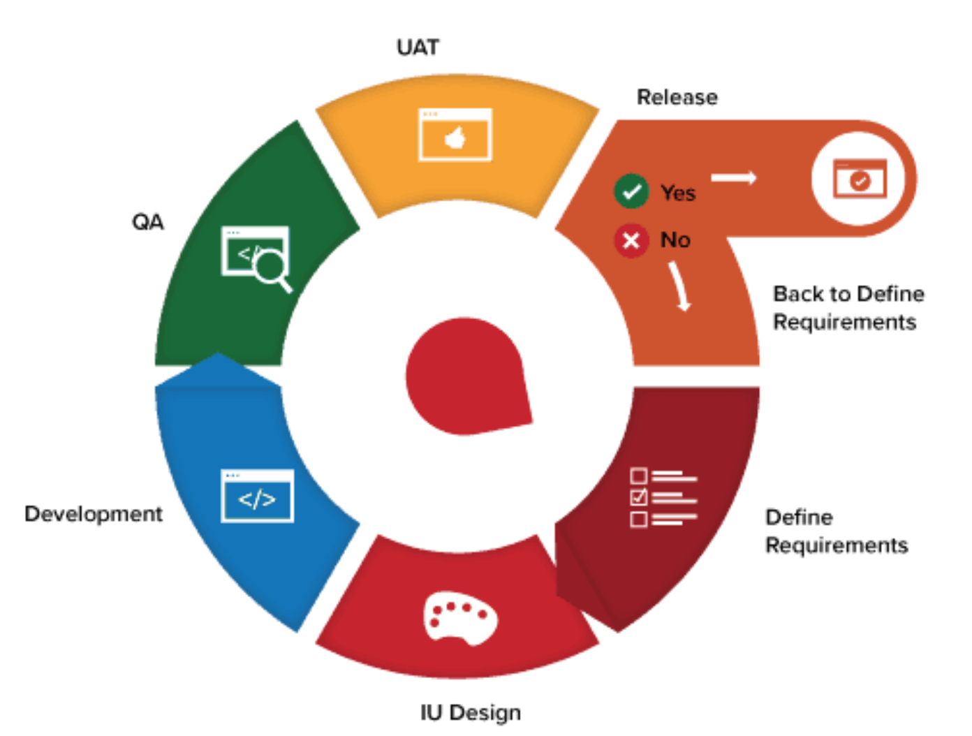

**Figure 1. Project Iteration Detail;  
Source:** [**https://www.smartsheet.com/understanding-agile-software-development-lifecycle-and-process-workflow**](https://www.smartsheet.com/understanding-agile-software-development-lifecycle-and-process-workflow)

The requirements are collected by interviewing the customer representing the City of Pasadena through meetings and phone conversations. Before the release phase of each iteration, the customer provides feedback and approves any possible requirement change that must be implemented during the next iteration.

## Project Management Processes

The Chatbot’s management processes follow the Project Management (PM) standards as defined in the guide to the Project Management Body of Knowledge from the Project Management Institute (PMI) to manage projects. This includes initiating, planning, executing, monitoring and controlling, and closing of the project. The initiation process begins with uncovering the initial requirements and identifying the members of Team 2, the project manager, and the stakeholders. The planning focuses on creating the Work Breakdown Structure (WBS), determining the schedule, determining the roles and responsibilities, planning the communication, performing risks identification, and management plan. The execution entails performing the work according to the PM plan, evaluating the team and project performance. The monitoring and controlling processes are conducted on a daily basis through team meetings where the status of important project activities is reviewed, and issues are discussed or escalated as necessary. All action items are tracked, and performance is measured against project metrics, which will be expanded on in section 5 Communication Plan of this Project Plan document.

Furthermore, in this management process, management determines if there are any variances from the plan, requests for changes, and informs the stakeholder of any approved changes. The final process is the closing of the project, which occurs when the work is completed, and the requirements are confirmed after successful acceptance testing. This is the phase when the completed Chatbot is delivered to the customer and resources are released.

## Project Support Processes

Configuration Management (CM) is the process of identifying, controlling, and auditing configuration items. The CM's role in this project is to maintain the integrity of the project software, data files, development tools, and associated documentation as they evolve through the delivery life cycle. Team 2 will use a Git repository for version control to maintain documents and components of the Chatbot system. With every release, the components will be labeled accordingly, and a quality review is performed to ensure the build is migrated to the proper environment.

## Project Organization

### ***Project Team***

The project is organized using the Trello application which allows all team members to view deadlines and the task assigned to them. Tasks or boards are color-coded and make it easy for members to know which milestone they are working on. Once a deadline is complete, the user can add a checkmark so that the group knows that a specific part of the task is completed.

### ***Stakeholders Mapping***

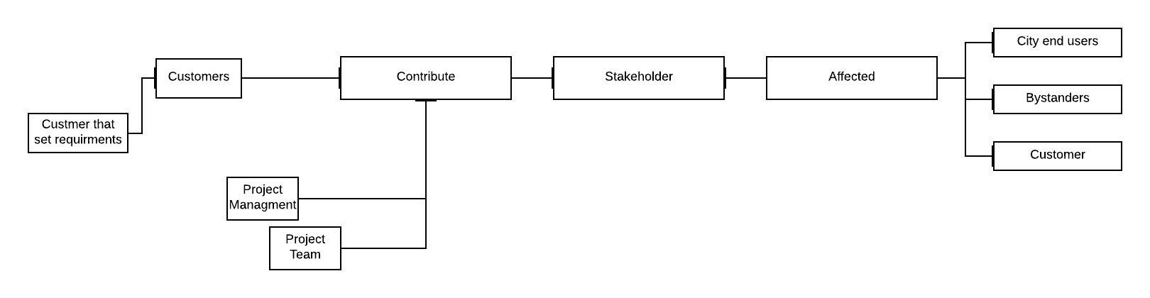

**Figure 2. Stakeholders Mapping**

# COMMUNICATIONS PLAN

This section defines how Team 2 plans to communicate information and status to the project stakeholders. Communications are taking place in different ways, including phone calls, e-mail, or through meetings on WhatsApp and Zoom platforms. All team members have the option to communicate with the customer through email or meetings to gather important project information and resolve any issues to better manage expectations. The communication matrix below documents how Team 2 will manage and control communications.

|  |  |  |  |  |
| --- | --- | --- | --- | --- |
| **Who-stakeholder** | **What info do they need** | **Why do they need it** | **When will they need it** | **How they will get it** |
| **Customer** | **High-level understanding Chatbot functionality** | **To understand what they are expecting from the functionality** | **Already have his version of the web site, will get an update when Project Functional Specification with User Interface and Chatbot is complete** | **Initial detail via the “Project Scope” section. Update via an extract of an executive summary from Functional Specification when it is produced, or a demo when the first version is complete** |
|  | **Progress of the project** | **To understand the progress the project is making** | **Weekly for informal updates** | **Copied on a weekly status report** |
| **Project Manager** | **Detailed functionality description** | **To approve specifications with the customer** | **Draft during specification phase and final version when the specification is complete** | **Review and approval of the draft and final functional Specification** |
|  | **Detailed project plan** | **To agree on business involvement for the project, key milestones** | **When the first draft of planning is completed** | **Project plan document for review and approval** |
|  | **Details of acceptance test process and test cases** | **To agree with the project on how the work will be deemed complete** | **During test preparation phase as defined in Project Plan** | **Acceptance test plan and acceptance test cases for review and approval** |
|  | **Detailed progress** | **To understand how the work is progressing, changes to the business involvement** | **Daily for informal updates, weekly for formal updates** | **Copied on the weekly status report** |
|  | **Details of requested changes** | **To authorized changes in functionality, changes in working schedules** | **As they are raised, either by the customer or project team** | **Formal project change request form review and approval** |
| **Project Team** | **General status update** | **To see how their work fits in** | **Daily for informal updates, weekly for formal updates** | **Daily in via team meeting** |
|  | **Requirement and design packages** | **To know what is expected of them** | **During panning and initiation** | **By having access to the project plan, and being informed in by the project manager** |
| **Project Facilitator: Dr. Mir** | **Project plan, deliverables of all Milestone** | **To plan staffing resources, help in risk planning, monitor the team progress** | **Every 3 weeks** | **Review of the deliverables and approval of the project plan** |

**Table 1. Communications Matrix**

# WORK PLAN

## Work Breakdown Structure

This section defines some high-level overview of the tasks, schedules needed to complete the Chatbot system. The breakdown structure can be found in figure 3 below.

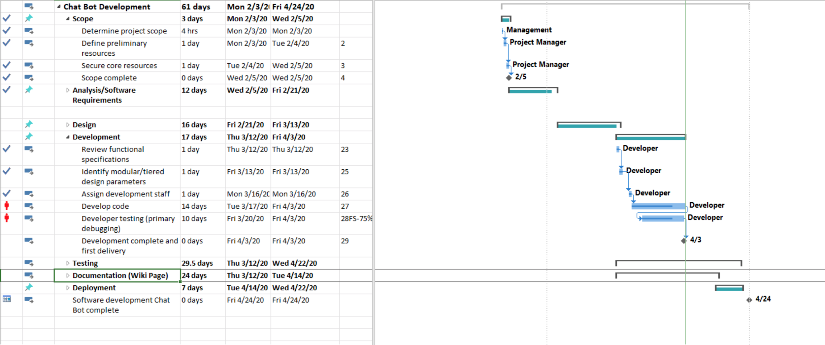

**Figure 3. Project WBS**

|  |  |  |  |  |  |
| --- | --- | --- | --- | --- | --- |
| **Name** | **Start** | **Finish** | **Duration** | **% Complete** | **Resource Names** |
| Determine project scope | Mon 2/3/20 | Mon 2/3/20 | 4 hrs. | 100% | Management |
| Determine preliminary resources | Mon 2/3/20 | Tue 2/4/20 | 1 day | 100% | Project manager |
| Secure core resources | Tue 2/4/20 | Wed 2/5/20 | 1 day | 100% | Project manager |
| Conduct needs analysis | Wed 2/5/20 | Mon 2/10/20 | 3 days | 100% | Analyst |
| Draft preliminary software specification | Mon 2/10/20 | Thu 2/17/20 | 5 days | 100% | Analyst |
| Review software specification | Mon 2/17/20 | Mon 2/17/20 | 4 hrs. | 100% | Project manager Analyst |
| Incorporate feedback on specifications | Tue 2/18/20 | Tue 2/18/20 | 1 day | 100% | Analyst |
| Develop a delivery timeline | Wed 2/19/20 | Wed 2/19/20 | 1 day | 100% | Project manager |

**Table 2. Project Completed Tasks**

|  |  |
| --- | --- |
| **Milestone name** | **Finish Date** |
| Scope complete | Wed 2/5/20 |
| Analysis and 1st Milestone Complete | Fri 2/21/20 |
| Design Complete | Wed 3/11/20 |
| Unit Testing Complete | Wed 4/15/20 |
| Integration Complete | Wed 4/22/20 |
| Documentation Complete | Tue 4/14/20 |
| Deployment Complete | Wed 4/22/20 |
| Chatbot Software Development Complete | Fri 4/24/20 |

**Table 3. Project Milestones Schedule**

## Resources

The following are the resources involved throughout the life cycle of this Chatbot project:

* Joseph Ogunsanya (Project Manager)
* Priva Leuga (Developer)
* Essaid Elboukhani (Lead Developer)
* Helen Abraham (Tester)
* Evelyn Akinlosotu (Tester)
* Vincent Seen (Developer)
* Jan Masouh (Developer)

**Note**: A trainer is not included in the resources because a wiki page will be available to address most of the issues a user may encounter. Table 4 and Figure 3 illustrate the project resources, work resources, scheduled dates, and estimated work hours.

|  |  |  |  |
| --- | --- | --- | --- |
| **Name** | **Start** | **Finish** | **Remaining Work** |
| Management | Mon 2/3/20 | Tue 4/14/20 | 148 hrs. |
| Project Manager | Mon 2/3/20 | Wed 4/14/20 | 60 hrs. |
| Developers | Thu 3/12/20 | Tue 4/14/20 | 328 hrs. |
| testers | Thu 3/12/20 | Wed 4/22/20 | 248 hrs. |
| Deployment team | Tue 4/14/20 | Wed 4/22/20 | 56 hrs. |

**Table 4. Resource Stats and Remaining work**

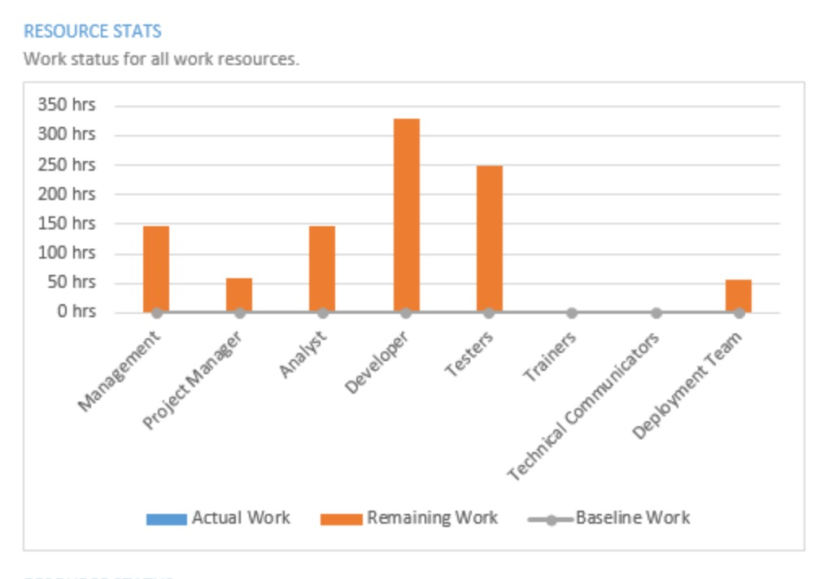

**Figure 3. Resources/Work Resources**

Infrastructure Resources:

* Git Repository <https://github.com/umgc/city>
* Web server for a test in the dev environment
* Laptop to each developer
* The wiki page for the project
* Web project management tool <https://trello.com/b/hW2QpKhW/umgc-team-2>

# MILESTONES

For information about the milestones please go to section 2.1.2

# PERFORMANCE AND METRICS

The chatbot should be able to open up and update without delay as well as support multiple users. The metrics will be from using JMeter and sending loads at the chatbot endpoint thus simulating heavy traffic hitting the chatbot simultaneously. The goal is to form a baseline to see how much traffic the chatbot can handle. We also want to load test the strength of the webserver, app, and API.

**Metrics**

Thread – Simulates a user. Messages can be attached. This can be grouped into thread groups.

Response – The amount of time from the moment that a user sends a request until the time that the application indicates that the request has completed.

Success – There was a successful response

Failure – There was a failure in the response. Failures begin to occur when the system is overloaded by threads.

Web Server Metrics – Send loads to the Web Server to help find errors in API deployment

App Metrics – Send loads to each layer of the app to determine any issues and how much it can handle.

API Metrics – API Performance affects mobile and web apps. We can load test this by sending loads to Dialog Flow and IBM Watson Assistant to determine the strength of the APIs.

# RISKS, CONSTRAINTS, ASSUMPTIONS, DEPENDENCIES

## Risks

**9.1.1 Risk Matrix**

This section lists the risks team 2 is considering and the probability of their occurrence. The likelihood of occurrence is rated as high, medium or low.

|  |  |  |
| --- | --- | --- |
| **Risk ID.** | **Risk Description** | **Likelihood of occurrence (high / medium / low)** |
| 1 | Insufficient time availability of the customer to provide feedback on the design layouts. | High |
| 2 | Lack of verifiable Chatbot use cases which may affect the validation of the end product | Medium |
| 3 | Some work completed by team 1 won’t work as expected with the chatbot integration | Medium |

**Table 6. Risk Matrix**

**9.1.2 Risk Mitigation**

The risks are defined for the risk management process, which is the process of planning for, identifying, assessing, and resolving project risks throughout this project life cycle. The purpose of this process is to identify potential problems before they occur so that risk mitigation activities can be planned and invoked as needed to prevent or lessen adverse impacts on achieving objectives.

The risks are identified using a risk management matrix. A low-risk impact is considered acceptable and identified with green color with a high chance of occurrence, a medium risk impact is that may or may not be acceptable and identified with a yellow color that will have a medium chance of occurrence, and a high-risk impact is critical and unacceptable and identified with a red color that will have a low chance of occurrence for our project.

|  |  |  |  |  |
| --- | --- | --- | --- | --- |
|  |  |  |  |  |
|  | **High** | **Risk ID 3** |  |  |
| **IMPACT** | **Medium** |  | **Risk ID 2** |  |
|  | **Low** |  |  | **Risk ID 1** |
|  |  | **Low** | **Medium** | **High** |
|  | **LIKELIHOOD** | | | |

|  |  |  |  |  |  |
| --- | --- | --- | --- | --- | --- |
| **Risk ID.** | **Risk Description** | **Mitigation Plan (what to do to avoid the risk occurring)** | **Contingency Plan (what to do if the risk occurs)** | **Impact (what the impact will be to the project if the risk occurs)** | **Likelihood of occurrence (e.g., %, or high / medium / low)** |
| 1 | Insufficient time availability of the customer to provide feedback on the design layouts. | Use all communication channels to get details | Advise the customer with design and layout ideas | The Chatbot service won’t be completed on time | High |
| 2 | Lack of verifiable Chatbot use cases which may affect the validation of the end product | Ask the customer for more use cases | Future UMGC’s team can continue training the Chatbot | Only a few services are provided by the Chatbot | Medium |
| 3 | Some work completed by team 1 won’t work as expected with the chatbot integration | Both teams should work together for common objectives | Work with team 1 to adjust their work or implementations to match the chatbot requirements. | The implementation of the chatbot won’t be as intended | Low |

**Table 7. Associated Risks and Mitigation Plan**

## Constraints, Assumptions, and Dependencies

UMGC Team 2 works with the customer to define the assumptions and constraints in place for the Chatbot section of the UMGC City project. All issues are coordinated through the project managers of each team working concurrently on the UMGC City project. for resolution according to the project constraints. Assumptions and constraints are detailed for this development effort. These assumptions and constraints are specific to the Chatbot service and submitted before work is authorized.

The following assumptions were determined concerning the Chatbot system:

* The project will follow the Scrum framework and comply with all applicable standards of the City of Pasadena.
* The Chatbot services created to support this project will be reusable by other cities.
* Team 2 shall manage and use open-source and no-cost systems to support the Chatbot system.
* It is assumed that the City of Pasadena will encourage individuals assigned to this project to place a high priority on tasks associated with the Chatbot system. Lack of customer participation and involvement usually leads to project failures.

The following are considered dependencies and constraints for the Chatbot service:

* Availability of Team 2 members with the appropriate skill sets, as required throughout the project life cycle.
* Availability of the customer for business and technical reviews.
* Access to the current IT infrastructure, which includes databases and APIs used by the City of Pasadena.

# FINANCIAL PLANS

The financial plan is not available for the project because the project is held by the UMGC student, and the customer is not willing to provide financial resources. The project is completely voluntary and is designed as a template for future use by other cities. Free and open-source frameworks and technologies that support both the development of the Chatbot and the user interface were required for this project.

# 11 GLOSSARY

|  |  |
| --- | --- |
| **Term** | **Definition** |
| **Chatbot** | a computer program designed to simulate conversation with human users, especially over the Internet. |
| **Work Breakdown Structure (**[**WBS**](https://drive.google.com/open?id=1UlXHnKNZLa8eg8ZpnCVL7zcRYRuBwQ4v)**)** | A work-breakdown structure in project management and systems engineering |
| **Change Request** | A change request is a document containing a call for an adjustment of a system; it is of great importance in the change management process. |
| **Milestones Document** | A milestone list is a project management document that identifies all project milestones. A milestone is a significant event or a point in a project. |
| **Risk Management** | Risk Management is the systematic process of identifying, analyzing, and responding to project risks. |
| **Mitigation Plan** | The risk mitigation step development that is designed to manage, eliminate, or reduce risk to an acceptable level. |
| **Project Management Institute** | The Project Management Institute is a global nonprofit professional organization for project management. |